Research Update 4

1. State Before This Work
The last update finished the Phase 2.5 library, the three command-line tools, the cluster wrappers, and the RapidMiner smoke test. Three things were still open: the noise-score calibration had to be hardened and rerun on the full mirror ladder, the aggregate JS divergence run on the full noisy set (datasets 61 to 120) had not been done, and several code review findings were noted but not fixed.
This update covers May 25 to May 30, about 20 hours of work. The goal was to finish everything that must be done before Phase 3 modeling can start: calibrate the noise score on a pooled ladder, close every open review finding, add the diagnostics the next meeting needs, run PSD and JS on the full noisy dataset, compare the noisy result to the clean one, and reconcile the Dataset 39 metadata fix.

2. Pooled Calibration of the Noise Score
The pilot ladder in the last update used a single triple: Dataset 1 paired with Dataset 61 and Dataset 91. That is enough to test the method, but the production noise score should not depend on one clean dataset. The pooled calibration ran over every clean dataset in 1 to 30 that has both its 1 percent mirror and its 5 percent mirror. That gives 30 mirror ladders and 7,525 paired operating points instead of one ladder of 102 files.
The pooled run promoted 10 metrics across the PSD and wavelet families. The cross-channel and chatter families abstained, which is how the family-vote rule should behave on simulation noise. There were zero inverse indicators. The strongest promoted metrics are the wavelet sigma on the tool position channels, the PSD noise floor ratio on Forcex, and the PSD spectral entropy on Forcex and xtpos.
The mode-label distribution from this calibration is the headline number for the meeting. Clean datasets 1 to 30, inside the pool, flag as broadband noise 1.6 percent of the time. Clean 31 to 60, the held-out half of the clean set, flag 0.3 percent of the time. The 1 percent noise mirrors flag at 18.7 percent. The 5 percent noise mirrors flag at 95.5 percent. The held-out clean rate matters most, because it shows the rule generalizes off the pool, not just on it.
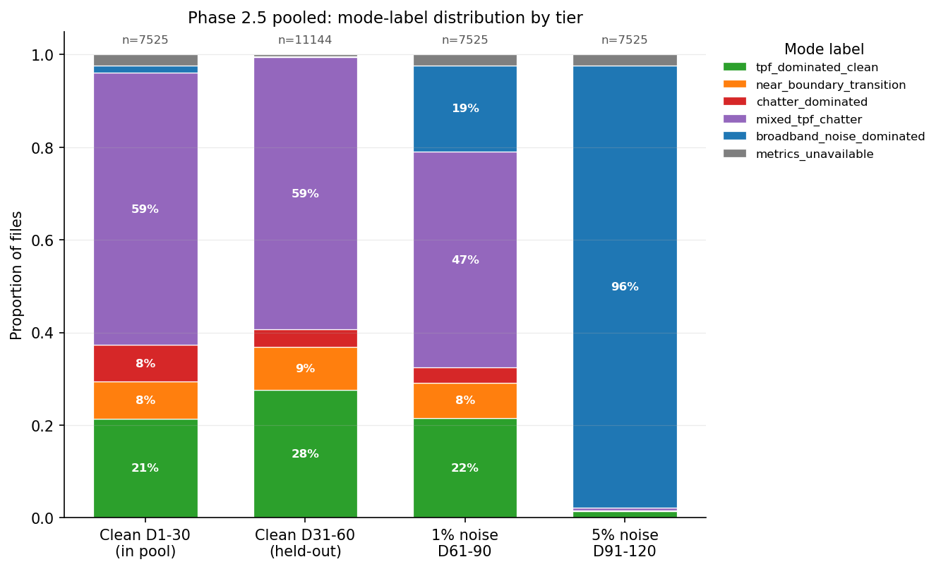
Mode-label distribution by tier, 33,719 files, 60 clean and 60 noisy datasets. The clean tiers stay mostly in TPF-dominated and mixed labels and rarely flag as broadband noise. The 5 percent noise tier is almost entirely broadband noise. The 1 percent tier sits cleanly between them. Phase 3 will use this calibration as a per-file sample weight.
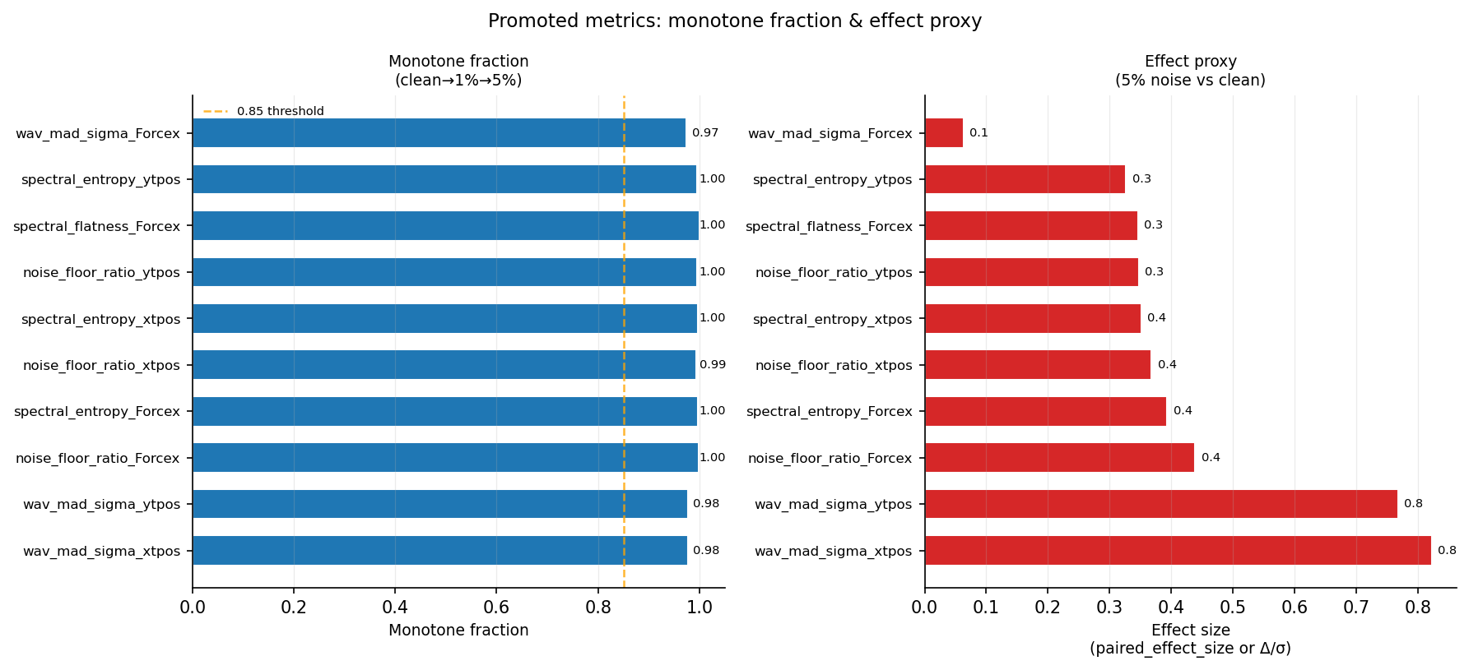
The 10 promoted noise metrics from the pooled calibration. The wavelet sigma on tool positions and the PSD noise floor and spectral entropy on Forcex are the strongest. The cross-channel and chatter families abstained, as expected on simulation noise.

3. Closing the Production Review Findings
Seven code review findings were open at the start of the week. Six are now closed with test-driven changes, and one is left open for a later session. All six landed in one batch with no conflicts. The local test suite grew from 38 tests to 68.
The findings, in short:
- The extraction script now fails closed when the canonical reader is missing, with an opt-in flag to allow the old generic H5 fallback.
- The cross-channel coherence now applies one common finite mask across the channel pair, so a NaN at different indices on the two channels no longer drives the coherence to zero.
- The noise score now averages inside each family first, then across families, so the PSD family cannot out-vote the wavelet family just because it has more metrics.
- The calibration step now refuses any metric whose paired-row coverage is below 80 percent, on top of the existing monotone and Mann-Whitney gates.
- The Pareto front script now inner-joins the baseline and each variant on dataset and file, so a filter that drops the hardest files cannot look better than it is.
- The mode assigner now rejects positive and negative infinity, not just NaN, on every promoted metric input.
The archive folder is now declared local-only, with a tracked manifest that records what each archive subdirectory holds and why it is not synced. This closes the silent-deletion risk from the last review.
One finding stays open. Four SINDy helper files live on the cluster but not in the local tree. They are needed for local reproducibility of the extractor, not for any current production run, and a single rsync will pull them when convenient. The new fail-closed extractor already checks for them.

4. Aggregate JS on the Full Noisy Set
The last update covered the full clean JS curves on 60 datasets. The full noisy run on datasets 61 to 120 ran this week. The reference rule matches the clean run: low b/blim quantile of 0.10 with a 0.80 stability floor, so the noisy curves read directly against the clean ones. Two cluster jobs ran with zero failures: 14,798 files, 59,192 signal rows, 116 of 116 reference rows usable.
The noise-robustness story holds. The score stays low and flat below the stability boundary on all four signals, and rises across b/blim equal to 1.0 just as it did on clean. On the dominant facet, Forcex with four teeth and a climb cut, the noisy result tracks the clean result closely. The table puts them side by side.
b/blim bin | Clean JS (Forcex, 4 teeth, climb) | Noisy JS (Forcex, 4 teeth, climb)
0.00 to 0.50 | 0.00034 | 0.00039
0.50 to 0.75 | 0.00825 | 0.01007
0.75 to 1.00 | 0.01342 | 0.01315
1.00 to 1.25 | 0.02124 | 0.02454
1.25 to 1.50 | 0.04190 | 0.05747
1.50 to 2.00 | 0.08225 | 0.08871
2.00 to 3.00 | 0.14274 | 0.10338
3.00 to 5.00 | 0.27375 | 0.21256
5.00 and above | 0.41837 | 0.34266
The noisy curve has almost the same shape as the clean curve in the decision region around the stability boundary, and runs a bit higher than clean in the middle bins. The Phase 3 spectral loss has to react to the rise across b/blim equal to 1.0, and that rise survives noise. The top three bins sit slightly below clean. This is a facet-composition effect, not a robustness failure. Noisy 61 to 120 mirrors only clean 1 to 30, so the highest b/blim bins draw on a single tooth-by-cut-direction facet, while the same bins on the clean side draw on four. A strict head-to-head comparison restricted to clean datasets 1 to 30 is queued and would remove this effect.
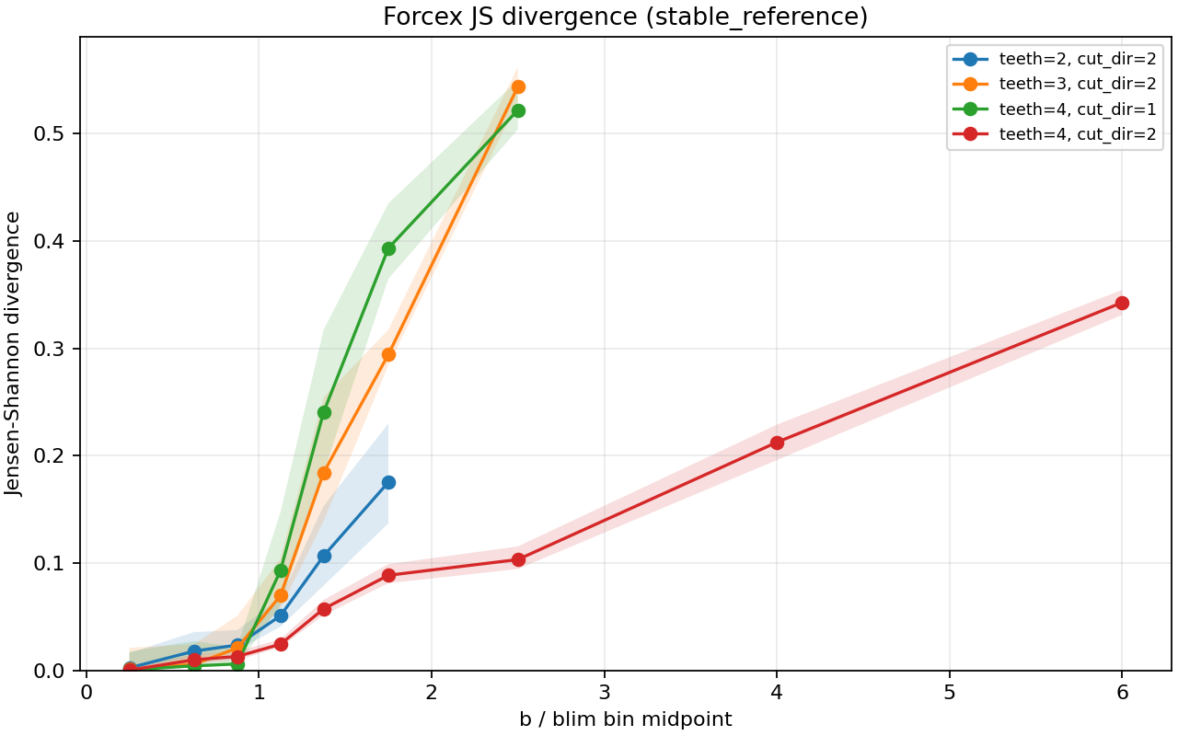
Full noisy 60 datasets, Forcex. The score stays low and flat below the boundary and rises across b/blim equal to 1.0. The shape matches the clean curve in the decision region. The slight tail dip above b/blim equal to 2 is a facet-mix artifact, documented separately.
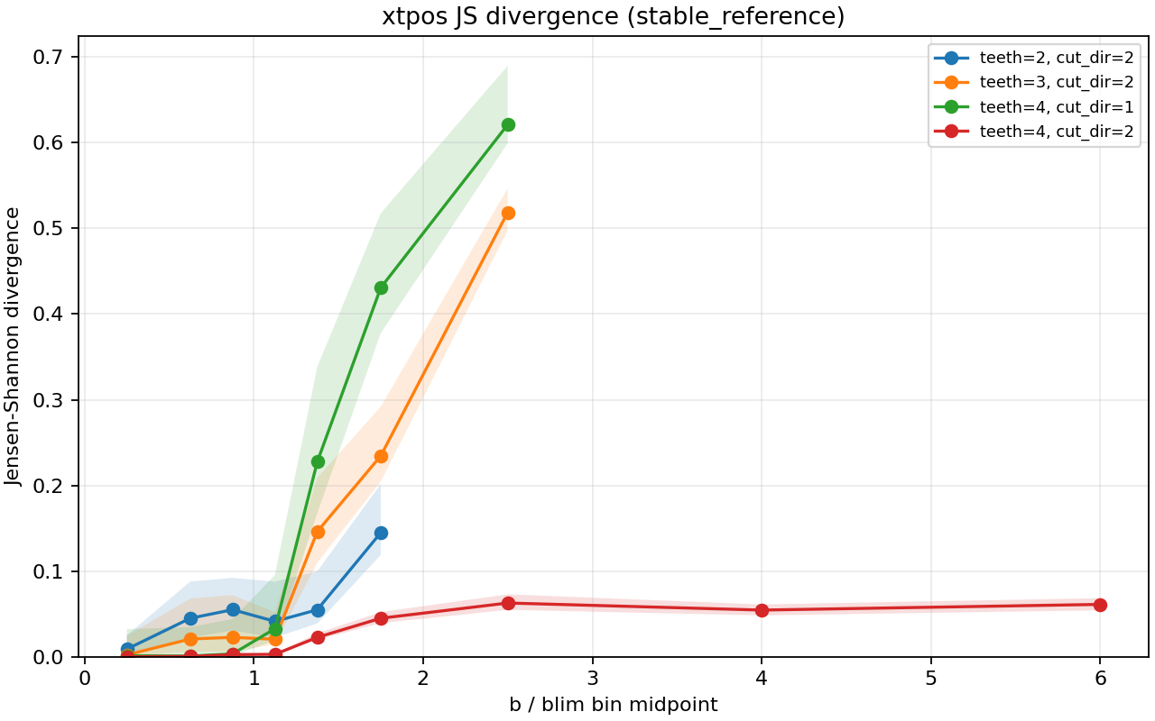
Full noisy 60 datasets, tool position x. Same boundary-aligned rise as the force signal, at a lower magnitude. Tool position carries less stability information than force under noise, which matches what the clean run showed.

5. Diagnostics for the Meeting
Two diagnostic scripts let the calibration story be discussed honestly at the meeting, not just summarized.
The first plots the per-tier mode distribution and the per-dataset broadband rate. It produces the headline 1.6, 0.3, 18.7, and 95.5 percent numbers, and it marks the few clean datasets where the broadband rate runs unusually high.
The second ranks those clean false-positive datasets. On the real local mode labels, Dataset 23 ranks first at 20.5 percent, then Dataset 12 at 10.3 percent and Dataset 13 at 6.9 percent. The script will report the per-metric driver once the full noise-metrics CSV from the cluster is fed into it. The aim is to learn, before treating any of these as a real false positive, whether those clean datasets are chatter-heavy regimes where the broadband label is correct, are missing metrics, or are threshold artifacts.

6. Where This Stands Against the Schedule
The clean side of Phase 2 was already done before this week. This week added the pooled noise calibration with 10 promoted metrics, six closed review findings, the two diagnostic scripts, and the full noisy JS run on 60 datasets. A calibrated rule, not a placeholder, now produces the mode labels on all 33,719 files in the noise-metrics CSV.
So everything Phase 2 and Phase 2.5 owe Phase 3 is in place: a per-file noise score for sample weighting, a per-file mode label for conditioning, stable-reference JS curves on the full clean and noisy data for the spectral loss head, and provenance-verified b/blim for the supervised label. The Phase 3 MLP baseline can start now, alongside the next steps in Section 8.

8. Summary
Phase 2 was the bridge between the raw machining data and the Phase 3 model. The goal was to turn each cut into a numeric measure of how unstable it is, in a form the model can learn from. Here is what Phase 2 produced and what it hands to Phase 3.
The spectral pipeline. Every raw file became a power spectrum, the spectrum was compared to a physics-only stable reference, and the result was scored with Jensen-Shannon divergence. On all 60 clean datasets and all 60 noisy datasets, the score stays low and flat while the cut is stable and rises smoothly across the stability boundary at b/blim equal to 1.0. The rise is a graded severity measure, not a stable-versus-unstable switch. This is the spectral signal the Phase 3 spectral loss head will train against.
Noise robustness. The noisy 60 run, at 1 percent and 5 percent simulated noise, kept the same boundary-aligned rise, and in the middle bins the rise is actually stronger under noise. This is the main robustness result so far. It says the spectral loss works on data that is not perfectly clean, a property the eventual hardware data will need.
Noise characterization. The Phase 2.5 library produces 44 candidate noise metrics per file. A pooled calibration on 30 mirror ladders and 7,525 paired operating points kept 10 of them, all in the PSD and wavelet families, all monotone in noise level, all with coverage above 97 percent. Each of the 33,719 files now carries one of seven mode labels and a calibrated noise score. The held-out clean false-positive rate for the broadband-noise label is 0.3 percent, and the 5 percent noise detection rate is 95.5 percent. The gate detects noise reliably without erasing chatter or TPF structure on clean data.
Label provenance. The stability label is verified end to end. The b/blim column equals b_mm divided by blim, the label is exactly int(b/blim >= 1), and the blim values match the raw stability-boundary files for every operating point inside the boundary grid. The supervised target for Phase 3 is not corrupted anywhere in the pipeline.
Code state. Six of seven review findings are closed with their own tests, the local test suite is at 68 of 68, the archive folder is local-only with a tracked manifest, and the cluster sync wrapper uses one Duo prompt per transfer. The pipeline is in a state where Phase 3 can pull on it without quiet failures.
How this helps Phase 3. Phase 3 is a supervised model first, then a physics-informed neural model. Phase 2 hands it four things: the mode label as a conditioning input, the noise score as a per-file sample weight, the 10 promoted noise metrics as auxiliary scalar features, and the stable-reference JS curve as the spectral fidelity loss head. The verified b/blim is both the supervised target and the input to the eventual physics residual.

9. Time Spent
This update covers May 25 to May 30, about 20 hours of work.
Work | Hours
Pooled mirror calibration on 30 ladders and result review | 3.0
Closing six review findings with TDD, integration, and full suite | 5.0
Mode threshold retuning against pooled clean p95 | 1.0
Phase 2.5 meeting figures script | 1.5
Clean false-positive diagnostic script | 1.5
Self-contained sbatch wrappers for noisy 61 to 120 PSD and JS | 1.5
Noisy JS result analysis and clean-versus-noisy comparison | 1.5
SSH multiplexing fix on the cluster sync wrapper | 0.5
Dataset 39 teeth verification and cross-check across 120 datasets | 1.0
Archive policy and manifest | 0.5
Forcey Dataset 19 diagnostic and v3 calibration staging | 1.5
Research update | 1.5
Total hours | 20.0
The two biggest blocks were the code-hardening batch and the noisy JS run with its clean comparison. Both are the kind of work that has to land before Phase 3 modeling starts, even though neither moves the modeling itself forward.

